**Cementing under High Temperature and High Pressure (HTHP) Conditions: A Fully Coupled Porothermoelastic Solution Using Plug and Abandonment (P&A) as Case Studies**

Yunxing Lua & Andrew P. Bungera,b,*

a Department of Civil and Environmental Engineering, University of Pittsburgh, United States of America.

b Department of Chemical and Petroleum Engineering, University of Pittsburgh, United States of America.

* Corresponding author. Tel.:+1 412-624-9875; Fax: +1 412-624-0135

E-mail address: bunger@pitt.edu

**Abstract**

Using the primary cementing in P&A as an example, the fully coupled porothermoelastic-osmosis-filtration (PTEOF) model is presented here. It has been demonstrated that under high temperature and high pressure (HTHP) conditions, the induced pore pressure in low permeability material such as cement can be very large, which greatly reduces the effective stress and can even extend it into the tensile region. This reduced effective stress phenomenon will, in general, increase the probability of failure that may occur in different types of cement. These phenomena are firstly ever described as permeability penalty. By the pairwise bivariate analysis, the properties that are important for the HTHP cementing are found out. Based on these results, two new concepts of permeability, forgiveness cement and phase-change cement, are proposed here for the future of HTHP cementing design. Furthermore, by adapting the traditional scaling analysis approach, three zones (safe, transition, and damage) with clear boundary values shown in the (Hydro-Thermal Non-Dimensional parameter) and (Mechanical Non-Dimensional parameter) plot, which gives the cementing researchers and practitioners a direct, meaningful guidance about the risk of tensile failure the cement is taking when placed under HTHP conditions. More importantly, the implications of our results challenge the prevailing HTHP cementing principles and provide a new perspective of design and guidance, by addressing the porous intrinsic nature of cement.

1. Introduction

Properly designed and executed cementing operations are important as they are widely applied across the various earth science-related geotechnical applications, such as radioactive waste disposal, deep-well plug and abandonment (P&A), drilling and completion in unconventional reservoir, Enhanced Geothermal System (EGS) reservoir, and carbon capture utilization and storage (CCUS) (Gruber et al., 2021; Hargis et al., 2021; Koťátková et al., 2017; Olson et al., 2015; Vrålstad et al., 2019). A successful cementing job avoids the unnecessary deficiencies during the life circle of each project, which improves the system efficiency and makes the project more environment friendly. Despite the advancements in technological development of cementing materials over the last several decades, the quality of cementing is always associated with some deficiencies, mainly due to the harsh environments where cement is placed (Ahmed et al., 2020; Allahvirdizadeh, 2020; Kiran et al., 2017). Taking P&A as an example, over the years and across companies, the upper range of the reservoirs’ pressure and temperature have been pushing up to 40000 psi and 600 Fahrenheit (DeBruijn et al., 2008; Khalifeh et al., 2020). However, the cement is originally designed for low temperature and low pressure conditions, and under such harsh conditions, its stability over an extended period of time is unknown. To leverage this problem, extensive, pioneering research has focused on reinforcing the cement by adding various additives, which aim to provide better mechanical and hydraulic properties, thus hoping to maintain the system integrity under the extreme conditions (Cai et al., 2022; Ge et al., 2018; Katende et al., 2020; Krakowiak et al., 2018; Massion et al., 2021; Massion et al., 2022; Qin et al., 2021; Samarakoon et al., 2022).

However, the identifications of the “better” mechanical and hydraulic properties of cement under the scenario of HTHP are still unclear, and it does require a more comprehensive and thorough study to highlight the challenges associated with HTHP cementing so a proper solution can be developed to better suit these challenges. Known as the cementitious saturated porous material with permeability ranges from mili-darcy to nano-darcy (Banthia et al., 1989; Goto et al., 1981; Meng et al., 2021; Picandet et al., 2011), the cement’s behavior can be heavily influenced by the thermo-hydraulic-mechanical (THM) coupling in the porous space, especially when it is experiencing large temperature and pressure variations. Within the permeability range mentioned above, a very large pore pressure could be induced by the THM coupling and the pore pressure would be progressively reestablished over the time, which will also lead to the changing of the effective stress and increase the possibility of shear failure, hydraulic fracture, or even tensile failure (Ghabezloo et al., 2010). While THM coupling phenomena in the porous media has been studied by a considerable number of researchers, their applications have been mainly focusing on the wellbore stability during drilling and fluid injection into the borehole (Gao et al., 2017; Song et al., 2019; Tao et al., 2010; Zhou et al., 2009). The THM coupling effect in the cementing designs and operations has rarely been properly considered and fully investigated under the HTHP conditions, which could result in jeopardizing the cementing integrity and lead to many serious consequences. More importantly, these THM coupling related issues cannot be addressed by any of the current available additives, because none of them can change the intrinsic nature, i.e. the porous structure, of the cement.

To include these mutual interactions between thermal, hydraulic, and mechanical systems in the non-isothermal conditions, Biot (Biot, 1977) firstly extended the traditional theory of poromechanics to include the uncoupled thermal effects by incorporating the thermos-molecular diffusion and dynamic forces using the variational Lagrangian thermodynamics approach. Later on, the thermal diffusion process was coupled in solid and fluid deformation by Derski (1979), as well as others (Bear et al., 1981; Kurashige, 1989; Smith et al., 1993). The abovementioned porothermoelastic analytical solutions are obtained by neglecting the non-linear term associated with connective heat transfer, thus it is called the linear porothermoelastic model, which is especially prevailing for low permeability material (Chen et al., 2005; Delaney, 1982; Gomar et al., 2014; Wang et al., 2003). Within the framework of linear porothermoelasticity, substantial studies have been performed for coupled THM behavior of isotropic porous media to understand the mechanism of relative cases, but most of the works assume the fluid flux and heat flux are dominated by the pore pressure gradient and thermal gradient, respectively (Ghassemi et al., 2002; Ghassemi et al., 2009; Valov et al., 2022). That is to say, the thermo-osmosis denoted by (fluid flux generated by thermal gradient) and mechano-caloric effects denoted by (heat flux generated by pore pressure gradient) are neglected in the transport equations

,

.

Note that the mechano-caloric coefficient is also known as the thermal filtration coefficient (Cheng, 2016). However, as for porous material with low permeability, these two effects actually play important roles (Gonçalvès et al., 2010; Roshan et al., 2015; Trémosa et al., 2010). For example, Carnahan (1983) has shown that the thermo-osmosis flow through kaolinite can be two orders of magnitude higher than Darcy’s flow near the nuclear waste repository. Thus, when designing the cementing under HTHP conditions, both the thermos-osmosis and mechano-caloric effects should be taken into consideration. To the best of our knowledge, under the HTHP conditions, their influences on the cement integrity are still unclear (is denoting for the fluid flux and is the heat flux).

By introducing the so-called fully-coupled porothermoelastic model, which incorporates both the thermo-osmosis and the mechano-caloric (thermal filtration) effects, dubbed here as “porothermoelastic-osmosis-filtration” (PTEOF), the present work used primary cementing in P&A as an example to highlight the cementing challenges that are associated with HTHP conditions, by considering the porous intrinsic nature of cement and its related THM coupling phenomenon. The motivations behind creating the PTEOF model are to have a comprehensive understanding of the cement’s behavior under the HTHP conditions, and to build up a general framework and solutions for future cementing studies and analysis. Drawing on the important contributions of Sarout et al. (2011) on modifying the theory of linear chemo-poroelasticity into a convenient form, whereby the interpretations of the phenomenological parameters can be clarified, this paper will not only include detailed parametric studies of PTEOF, but also include an important discussion on the implications of these results, and provide guidance from a new perspective of cementing design under HTHP conditions.

2. Model Basics

Following the sign convention in Detournay et al. (1988), positive stress is considered to be tensile within the present work. Based on the fundamental work of Cheng (2016) and Wang (2017), one obtains the constitutive equations, with the hydraulic and thermal coupling term

, where ,

whereandis volumetric strain tensor and total stress tensor, respectively. is the variation of fluid content per unit volume, is entropy density,is pore pressure change from virgin pore pressure, and is temperature change from the reference temperature, . The material constants include the drained bulk modulus tensor, Biot effective stress coefficient, Skempton pore pressure coefficient, coefficient of volumetric thermal expansion of porous media frame , coefficient of volumetric thermal expansion of variations in fluid content in the solid-fluid system(Cheng, 2016), and represents the specific heat of the porous medium at the reference temperature. From the constitutive equations, it shows that the deformation of the solid frame is caused by the effective stress and the temperature change. The fluid phase in the porous medium is not only deforming with the solid frame, but at the same time, driven by the pore pressure gradient and thermal forces, causing the pore fluid entering or leaving the solid frame of unit volume. Lastly, the stress and temperature change will cause the change of entropy of the porous system based on the generalized-energy relation. The entropy density is therefore a function of volumetric strain of the solid frame, fluid content, and change in temperature. Thus, the constitutive equations relate and couple volumetric strain, fluid content, and energy variables , with total stress, pore stress, and temperature variables , with the material constants.

Note that one of these volumetric responses in Eq. 3 can also be obtained from contraction on

. (4)

Based on quasi-static equilibrium

,

and the strain-displacement relations

 ,

and by substituting both transport laws into the mass balance equations

,

,

the fully coupled diffusion equations

,

,

can be obtained. These two diffusion equations indicate that both fluid flux and heat flux are not only dominated by Darcy’s law and Fourier’s law, but that they are also influenced by the thermal osmosis effect and the thermal filtration effect. This is also where porothermoelastic-osmosis-filtration (PTEOF) so called “fully coupled” model comes in. One of the motivations to build up this fully coupled model is to facilitate further studies and analysis. For example, under some circumstances where thermal osmosis or thermal filtration are not considered important, the corresponding coefficient can always be taken as zero to simplify the model.

3. PTEOF solution for the primary cementing in P&A

3.1 Problem descriptions and boundary conditions

The present work will showcase the PTEOF model by using the primary cementing in P&A cases where the length of the primary plug is usually 50 to 100 times larger than its diameter (Eshraghi, 2013); it is appropriate to apply the generalized plane-strain assumption where the pore pressure and thermal diffusions only appear in the isotropic plane that is perpendicular to the length axis of the plug which is fully saturated. In line with the loading decomposition scheme proposed by Detournay et al. (1988) in the poroelasticity, the PTEOF model could be decomposed into three sub-loading cases to simplify the analysis, i.e. pore pressure loading (), temperature loading (), and isotropic far-field stress loading (), where the superscript i is denoting the stress field that is induced by the loading mode j. Thus, the boundary conditions at the outside surface of the primary cement plug for each of the loading modes can be written as follows (the subscript f denotes formation, subscript c denotes cement). Since the PTEOF model is linear, the principle of superposition will be used as a final step to obtain the final solution.

* Mode 1: , and 
* Mode 2: , and 
* Mode 3: , and 

3.2 Solution to the fully coupled diffusion equations

The solution method starts with obtaining a general solution of the fully coupled diffusion equations (Eq.9 and Eq.10). Note that the plane-strain assumption will lead to the conclusion that fluid and thermal transport will be directed only along the radial direction in the cylindrical coordinates system. Then, the first step is to eliminate  and in the diffusion equations by substituting in the constitute equation; this results in a new form of coupled diffusion equations

,

.

Next, by combining Eq.4 to Eq.6 and taking the body force to be zero, an extended form of the classical Navier equation is obtained as

.

Drawing on the important contributions of Sarout et al. (2011) which modify the theory of linear chemoporoelasticity into a convenient form, and whereby the interpretations of the phenomenological parameters can be clarified, we can then use the irrotational field assumptions to simplify the process of solving the Navier equation. When the displacement field is irrotational, i.e. is the gradient of a scaler, one can integrate Eq. 13 to obtain

,

where  and .

Thedoes not depend on the spatial coordinates and it is a spatially uniform function that often equals zero for infinite or semi-infinite domains (Detournay et al., 1993). But in the case of primary cementing in P&A, thewill not be taken as zero here. Next, by substituting Eq. 14 into Eq. 11 and Eq. 12, thecan be eliminated and it yields the coupled diffusion equation

,

where:

,

,

,

,

,

,

.

The diffusion equations in Eq.15 are coupled in terms of T and p, which can be transformed into uncoupled equations in terms of  and by using the Eigen decomposition approach developed by Sarout et al. (2011). This methodology starts by obtaining two eigenvalues,  and , of matrix. Then, the Eigen decomposition theorem (Weisstein, 2002) allows us to define a transition matrix, which is composed of eigenvalues and eigenvectors of , and temperature and pore pressure are

 ,

where

,

.

This transition leads directly to an uncoupled system of diffusion equations

,

where . Then, by applying the Laplace transform to the Eigen function

,

where , it becomes an ordinary differential equation in terms of variable, where is a function of the coordinators in the cylindrical system ρ, the Laplace parameter s, and the’s eigenvalue.

Therefore, the original coupled diffusion equation in Eq.15 has been transformed into the zeroth-order modified Bessel equation, with the general solution

,

where and  are unknowns that will be determined based on boundary conditions. And are the zeroth-order modified Bessel functions of the first and second kind, respectively.

The symmetry conditions of the primary cementing in P&A will ensure that equals zero, thus the pore pressure and temperature profile in the Laplace domain are

,

.

Within the framework of plane-strain conditions and irrotational field conditions, the displacement,, can be obtained by integrating Eq.14. At the same time, the strain-displacement relationship is

,

where  and .

Up to now, there are three unknowns in total, i=1,2,3 in the system. The first two unknowns,  and, come from the coefficient of the zeroth-order modified Bessel functions of the first kind, and the third unknown, , comes from the spatially uniform function from Eq.14 in the Laplace domain. In the process of deriving the above expressions for the pore pressure, temperature, and radial total stress (all in the Laplace domain), we can create three equations for these three unknowns

,

where

,,

,

,

,

,

,

.

So when given a value of s, thecan be readily computed, thus the solution can be numerically inverted to the time domain using Stehfest’s method (Stehfest, 1970), which has been proven to be efficient in poroelastic problems, and its details are shown in Appendix B.

4. Numerical Analysis and Discussions

The notations that are used for the modeling are summarized in Table 1 in Appendix A. The temperature difference between the formation and cement is assigned as, the virgin pore pressure of the formation is setup as Pa, and the far-field isotropic stress is setup as Pa (Snee et al., 2018; Xu et al., 2015; Zoback et al., 2003). In this section, we will firstly discuss the pore pressure profile and temperature profile that are induced by three different loads, respectively. Lastly, the superposition results of the effective stress will be summarized.



4.1 Pore pressure responses and thermal osmosis effect

The change of pore pressure in response to different loadings is a key component in poromechanical analysis. It is therefore of interest to firstly plot the evolution of pore pressure under three different loading modes, given the boundary conditions that are defined in the last section, while the influence of the factors of interest on the pore pressure will be analyzed and discussed later.



Figure 1a. Pore pressure change due to mode 1 loading, where the curves grade from gray to black as time increases



Figure 1b. Pore pressure change due to mode 2 loading, where the curves grade from gray to black as time increases



Figure 1c. Pore pressure change due to mode 3 loading, where the curves grade from gray to black as time increases

Fig.1a and 1b illustrate the evolution of the pore pressure profile along the radius in response to mode 1 loading (pore pressure loading) and mode 2 loading (temperature loading), respectively. Under the mode 1 loading, it is similar to the classical diffusion process; the pore pressure near the surface (r=1) is instantly raised to the level of pore pressure loading, and then the pore pressure is gradually diffused towards the center (r=0). However, in contrast to the gradual and smooth diffusion process of mode 1 loading, the pore pressure induced by mode 2 firstly peaks near the surface area (r=1). At the surface, the pore pressure returns to zero due to the boundary conditions setup. The pore pressure, however, decreases towards the inner core, because of the slow diffusion progress that is due to low hydraulic conductivity, hence a peak profile is developed. As time progresses, the pore pressure peak declines due to fluid diffusion, and at the same time, the inner core becomes heated as well, and so the peak moves towards the center. At even later times, the entire specimen is heated but the pore pressure is not yet dissipated due to the small fluid diffusivity, and as time further increases, the entire pore pressure dissipates and returns to zero everywhere.

For the pore pressure that is induced by mode 3 (isotropic far-field stress), as shown in Fig.1c, it firstly arrives at the highest value right after the loading (again, pore pressure at the surface reduces to zero due to the boundary conditions setup), but it gradually declines to zero due to the dissipation process as the time progresses. It should be noted that the magnitude of the pore pressure induced by mode 3 is much smaller compared to the pore pressure induced by mode 1 and mode 2. Even at the highest level of pore pressure, which is right after the loading is applied, the ratio of mode 3 induced pore pressure over mode 1 and mode 2 induced pore pressure is around 0.01%-0.02%. This is also in line with the findings from the classical pure poroelastic model that Detournay et al. (1988) concluded.

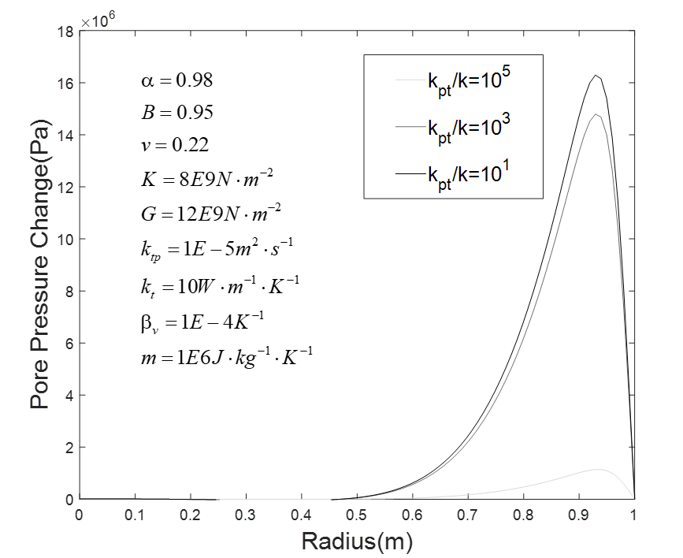

Figure 2. Various ratios of (thermo-osmosis’s influence) on the induced pore pressure (days)

Since the peak pore pressure usually occurs at an early time, we will use the smaller time at days after loading to illustrate the thermal osmosis effect on the induced pore pressure profile. Three different ratios (1, 103, 105) of are selected to show the different developments of the temperature induced pore pressure (Figure 2). Recall that the definition of the thermal-osmosis coefficient is understood as the passage of a fluid that is driven by a temperature gradient, but against the hydrostatic pressure (Denbigh, 1949). Taking the early time as an example, all three cases show a peak pore pressure near the surface region; however, the magnitude of the peak induced pore pressure is reduced when the thermos-osmotic coefficient is significantly larger than the hydraulic conductivity (i.e., =105).

4.2 Temperature response and thermal filtration effect

The temperature profiles under the mode 2 loading (temperature loading) are shown in Figure 3. As the time proceeds, temperature is increasing monotonically from the surface towards the inner core of the plug, and finally arrives at equilibrium, which is the equilibrium of the boundary conditions at the later time. Three different ratios of thermal conductivity over the thermal filtration coefficients are selected to show the impact of thermal filtration on the temperature profile, that is changed by the pore pressure gradient. As shown in Figure 4, among the three selected ratios, the maximum temperature difference induced by the pore pressure gradient is within 1 degree Kelvin. Furthermore, when the thermal conductivity is significantly larger than the thermal filtration coefficient (=105), the induced temperature differences are negligible under the current model settings and inputs.

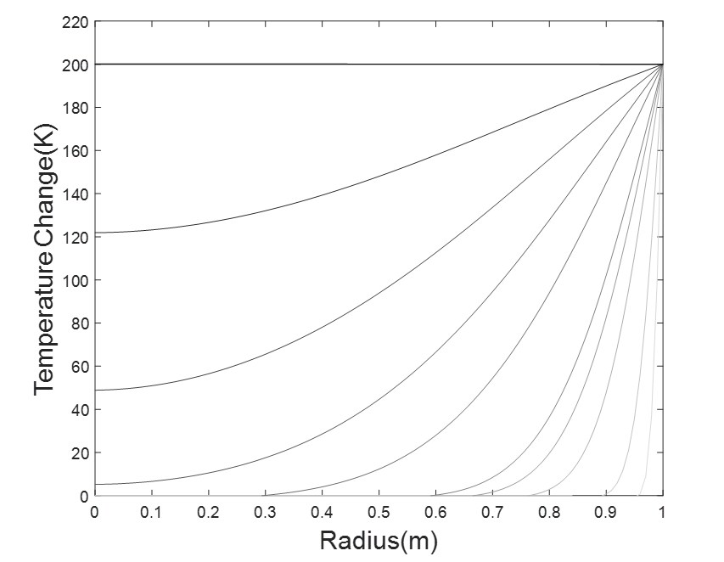

Figure 3. Temperature profile development under the mode 2 loading, where the curves grade from gray to black as time increases

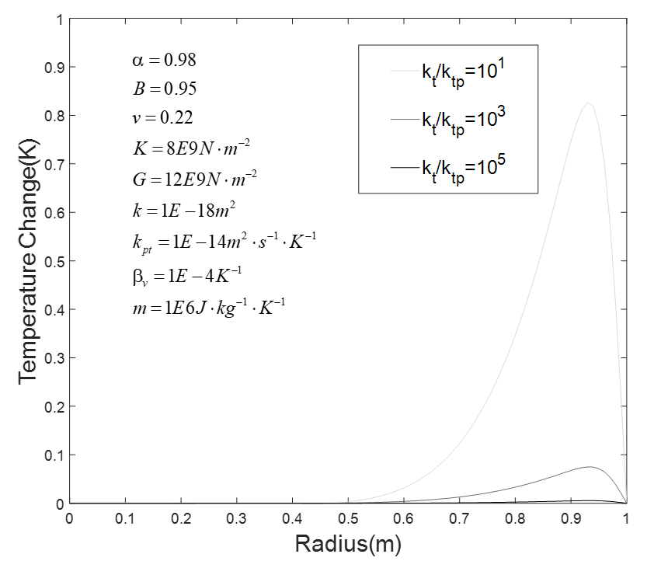

Figure 4. Various ratios of (thermal filtration’s influence) on the temperature profile change

4.3 Effective Stress

Many pioneering researches have shown that effective stress is a key factor in controlling the behaviors of porous medias in geotechnical and earth applications (Khalili et al., 2004; Skempton, 1984). Specifically, increasing pore pressure will reduce the effective stress, which can increase the possibility of many types of failures. Thus, appropriate estimation and calculation of total effective stress will greatly enhance the understanding of the behaviors of the porous system. As shown in figure 5, where the total effective radial stress (after superposition from the three loading modes) is plotted (again, tensile is positive), after the cement is placed under the boundary conditions mentioned previously at the early stage, the induced pore pressure will reduce the radial effective stress near the surface region, but the entire sample will still be under the compressive condition. However, because the diffusion process is very slow inside the sample, but the pore pressure is still accumulating due to the HTHP conditions, the effective stress will be further reduced, and a tensile region will be created inside the core. At a later time when induced pore pressure is fully dissipated, the radial effective stress will return to the compressive state again. This demonstration of the whole diffusion process of the PTEOF model with given inputs indicates that cementing under HTHP conditions will definitely induce a high value of pore pressure, which will lower the effective stress and even generate a tensile region as the results of pore pressure slowly diffuse inward. These increases the possibility of inducing different kinds of failures in the cement and jeopardizes the integrity of the cementing system, which will cause more severe consequences.



Figure 5. Total effective stress of cement under the conditions of HTHP, where the curves grade from gray to black as time increases (boundary conditions and input values of each parameter are stated at the beginning of this section)

4.4 Full parametric studies

It is worth mentioning that the system behaviors discussed in the last section depend on the different values of input parameters and the mutual interactions and group effects among them. If some of these parameters take on different values, the results can be much different. Thus, these phenomena will be investigated and discussed in this section. The analysis starts with assigning values (within a certain range that is summarized in Table 2 in Appendix A) to each parameter by the Monte Carlo method, which is a class of techniques for randomly sampling (Shapiro, 2003). Then, once these variables have been given values, they will be substituted into the constitutive equations and loading decomposition procedures discussed previously to obtain the effective radial stress, which will be categorized into tensile and compressive groups. The details of the above-mentioned procedures are summarized in the flowchart in Figure 6.

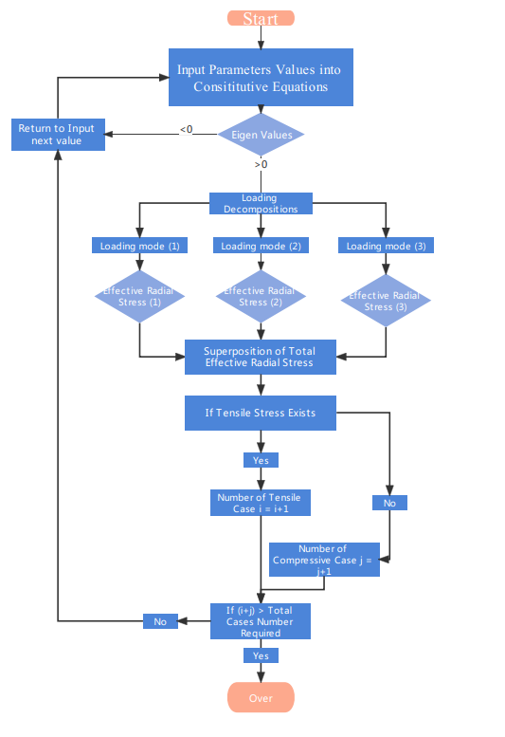

Figure 6. The Algorithm that is used to construct the fully parametric studies

4.4.1 Pairwise Bivariate Analysis for Each Variable

Following the procedures the flowchart described in Figure 6, a total of 3000 cases were calculated and then categorized into two groups: tensile (1727 cases) and compressive (1213 cases). Next, the relationship between each variable is firstly shown by the pairwise bivariate distributions that are shown in Appendix C. The non-diagonal elements are scatter plots which display the correlation between two variables and give a valuable insight on the distribution features of these variables. The lower and upper triangles formed by the diagonal are symmetrical. The diagonal elements are univariate distribution plots which are drawn to show the probability density function of each variable. It can be found that in the events of a tensile case, specific heat and permeability are more concentrated at their lower ranges, and the thermal conductivity and the thermal expansion coefficient differences are more concentrated at their higher ranges, whereas the rest of the parameters are almost evenly distributed along their whole range. This indicates a general trend that, within the framework of PTEOF, at higher values of  and lower values of and, there will be an increase in the probability of generating tensile radial effective stress increases.

A very interesting point can be found and discussed here. One current cement designing principle is that the lower the hydraulic conductivity, the better the system behavior. This cement designing philosophy is effective under most working conditions (i.e., ambient temperature and pressure) that cement is originally built for. However, when the cement is placing under the HTHP conditions, and poromechanics are taken into considerations, our results show that the lower permeability will actually increase the probability of the tensile case, which is considered detrimental to the integrity of the cementing system. This is mainly due to the fact that under the framework of porous media, lower permeability will greatly slow down the pore fluid diffusion process when the pore pressure is rapidly built up within the cement due to the HTHP boundary conditions. The accumulated pore fluid within the clogged porous system will build up excess pore pressure and the effective stress will thus be reduced or even extended into the tensile region, which will eventually jeopardize the whole system. That is to say, blindly pursuing low permeability regardless of the intrinsic porous properties of the cement itself will instead victimize the cement functions that provide mechanical support and zonal isolations. This phenomenon is firstly named here as permeability penalty. To avoid permeability penalty for cementing design under HTHP, perhaps the most favorable solution is to keep the permeability at certain ranges which can achieve the sealing function, but at the same time, allow for the diffusion of pore pressure that is built up by the HTHP conditions and therefore not cause unnecessary damage that could be induced by the excess pore pressure. This permeability-forgiveness design is actually very popular in pavement design of permeable porous systems (PPS) (Scholz et al., 2007), where one or two special drainage layers with relative higher permeability are designed in a more effective and efficient way that reduces the runoff rates in the storm while providing a hard surface for the traffic flow. The PPS design has been successfully turned into a wide variety of residential, commercial, and industrial applications in the last two decades (Drake et al., 2013).

It also worth mentioning that the specific heat capacity rarely got any attention in previous research of HTHP cementing design. However, based on our results, it does play a very important role, similar to the role of thermal conductivity, as a large specific heat capacity will slow down the heat transfer process and the thermal induced pore pressure build up progress will be delayed, which gives the pore fluid more time to dissipate. This provides a totally new perspective for creating a phase-change cement with high volume specific heat capacity but low thermal conductivity that is specially designed for HTHP conditions, which will have very promising and wide applications.

4.4.2 New Proposed Dimensionless Parameters

Although the pairwise bivariate distributions shown in Appendix C give a full picture of how each parameter will individually influence the system behaviors, the mutual interactions of different properties and their group effect cannot be analyzed from it. To solve this problem, scaling analysis is one the classical methods that is utilized. It is usually used to reduce a complex physical problem to a simpler version, prior to obtaining a quantitative answer, while also grasping the effects of various physical phenomena at the same time. We indeed can follow the typical procedures used to conduct the scaling analysis to investigate the mutual interactions and group effect of the PTOEF model. However, the new dimensionless numbers that result from the scaling process are often in very complicated expressions and lack a direct meaning at the physical level, and therefore can be very ambiguous in terms of many engineering applications. Thus, inspired by the spirit of the methodology of scaling analysis, we have adapted the results from the scaling analysis to manually compose two new composite dimensionless parameters with clearer physical meaning, and then have constructed a new plot by using these two parameters. This helps us to distinguish different system behaviors that can account for the mutual interactions and group effects among these different parameters, therefore making it easier for many cementing practitioners to pick them up and apply them to the real engineering problem. Thus, two new parameters are hereby proposed as follows:

, 

The first dimensionless number,, consists of the Biot coefficient, Skempton coefficient, thermal expansion coefficient of fluid and solid, as well as thermal diffusivity and fluid diffusivity, where the last two terms are obtained from the diagonal elements of the coefficient matrix in Eq. 15. This new proposedmainly contains the hydro-thermal properties of the porous media. It is thus named the Hydro-Thermal Non-Dimensional parameter (HTND). The second proposed parameter,, consists of three mechanical related components: Shear Modulus, Bulk Modulus, and Poisson’s ratio. Thus, it is named the Mechanical Non-Dimensional parameter (MND).

Given the new proposed parameters, a new plot can by generated to show the tensile and compressive spatial distribution cases based on ( HTND) and(MND). In Figure 8 (a), the same 3000 cases are replotted, where the red dot represents the tensile case and the green dot represents the compressive case. It can be clearly seen that the spatial distributions of the tensile and compressive cases in the- plot heavily depend on the, whereas both tensile and compressive cases are almost evenly distributed along theaxis. This indicates that the influence of on the system dominates when compared with . Futhermore, in Figure 8 (b), where is equally divided into 300 intervals, the probability of generating the tensile cases in each of these intervals is calculated. It is shown that in the area where is smaller than 0.07, the area is fully occupied by compressive cases and not one single tensile case exists in this region. It is thus called the safe zone, which means no tensile failure would occur within this range under the framework of the PTEOF model. When  increases from 0.07 to 1, the probablity of generating tensile cases gradually increases up to 100%. Both tensile and compressive cases could happen in this region, but with a higher value of , the possibility of generating a tensile case will be higher. This area is thus called the transition zone. When  is greater than 1, no compressive case exists within this range and it is fully occupied by tensile cases, which means the probability of generating a tensile cases is 100%. It is thus named the damage zone, which means when designing the cement under the HTHP conditions, if the resulting is landing greater 1, tensile damage will certainly occur in the cement.

Drawing on the conclusions above, it can be easily seen that the Bulk Modulus, Shear Modulus and Poisson’s ratio, which are considered as three of the most important mechanical properties, have very limited contribution to the system behavior when in terms of  is presenting. This actually challenges the current HTHP cementing design principles which always prioritize making the cement stronger and more ductile, hoping that the cementing system will thus have more resilience and less possibility of failure. However, based on our results, this actually may not help to maintain the cement integrity under the HTHP conditions. That is to say, when designing the cement under the HTHP conditions, rather than give the highest priority to these mechanical properties, more attention should be put into the components that keep the value of below 0.07, as to avoid any tensile damage.

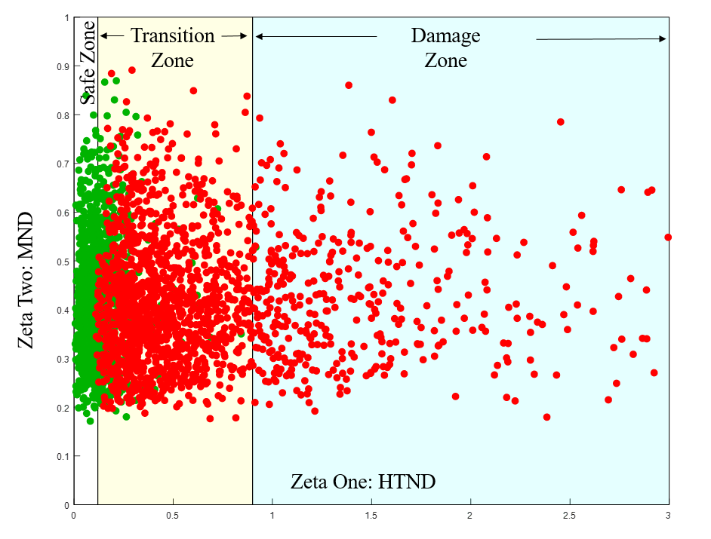

Figure 8 (a) (HTND) and(MND) plot with tensile cases (red color) and compressive cases (green color).

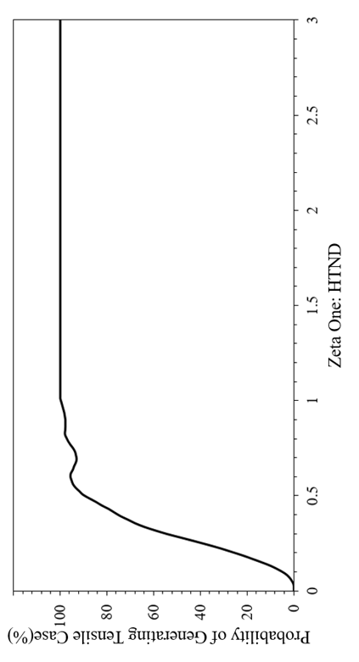

Figure 8 (b) The probability plot of generating tensile cases on different  (HTND) values

5. Conclusions

Using the primary cementing in P&A as an example, the fully coupled porothermoelastic-osmosis-filtration (PTEOF) model is presented here. It has been demonstrated that under HTHP conditions, the induced pore pressure in low permeability material such as cement can be so large that it greatly reduces the effective stress, and can even extend the cement into the tensile region. This reduced effective stress phenomenon will, in general, increase the probability of cement failure that may occur in different types. By the pairwise bivariate analysis, the properties that are important for the HTHP cementing are parsed out. Based on these results, two new concepts of permeability forgiveness cement and phase-change cement are proposed here for the future of HTHP cementing design. Furthermore, by adapting the scaling analysis approach, three zones (safe, transition, and damage) with clear boundary values are shown in the (HTDN) and (MDT) plot, to give the cementing researchers and practitioners a direct and meaningful guidance about how much tensile failure risk the cement is facing when it is placed under the HTHP conditions.

More importantly, the implications of our results challenge the prevailing HTHP cementing principles and provide a new perspective of design and guidance by addressing the porous intrinsic nature of cement. Current cementing improvement practices, such as adding different additives into cement to enhance its mechanical properties, will not change the fact that the new additive mix is still a porous media. While the new additive can change the pore space into various sizes as small as the nano-scale, without considering the underlying physical principles governing the mechanical behaviors under the framework of porous media, it sometimes will jeopardize the whole system instead. Our results indicate that when cementing under HTHP conditions, the mechanical properties, such as shear modulus and Poisson’s ratio, may not be the most important parameters to maintain the integrity of cement, and the low permeability will actually cause the tensile stress to damage the system. Thus, we are proposing a new cementing design principle of permeability forgiveness, which allows for some tolerance of permeability in order to avoid the permeability penalty.

Another important implication from our results is that instead of focusing on enhancing the mechanical properties, thermal properties, such as thermal conductivity, specific heat capacity, thermal expansion coefficient ratio, and the thermo-osmosis coefficient also deserve more attention. Our analysis shows that the magnitude of thermal induced pore pressure results from the competing process of thermal diffusion and fluid diffusion. Thus, slowing down the thermal transfer process becomes a key step in preventing the thermal load induced pore pressure damage. Certainly, reducing the thermal conductivity is the most direct method to achieve this goal. However, our results show that increasing the specific heat capacity is another efficient way to slow down the pore pressure build up progress. More importantly, it provides a totally new perspective of creating a phase-change cement with high volume specific heat capacity but low thermal conductivity that is specially designed for HTHP conditions, which has very promising and wide applications.

Acknowledgments

This research is supported by the National Academy of Science and Mathematics Gulf Research Program (NASEM-GRP) grant # 10002358 and the Project Research Team Members: Mileva Radonjic from Oklahoma State University, Raissa Ferron group from University of Texas Austin, Ipsita Gupta group from Louisiana State University and Pierre Cerasi from SINTEF. Thanks go to Charles Hager (PITT) for the outstanding technical contributions. We are grateful for the support of our entire research group who make the Hydraulic Fracturing Lab here at University of Pittsburgh and finally the postdoc scholar and graduate students from NASEM GRP funded project: Cindy Cao (OSU), Mercy Achang (OSU), Cody, Massion (OSU), Vamsi Vissa (OSU), Tamitope Ajayi (LSU), Farzana Rahman (UTA) and especially Hope Asala, who is no longer with us due to a tragic accident.

Appendix A: Table 1. Notations

|  |  |  |
| --- | --- | --- |
| Symbol | Definition | Unit |
|  | Biot effective stress coefficient | --- |
|  | Drained thermoelastic effective stress coefficient | N⋅m-2⋅K-1 |
|  | Skempton pore pressure coefficient | --- |
|  | Coefficient of volumetric thermal expansion of solid | K-1 |
|  | Coefficient of volumetric thermal expansion of porosity | K-1 |
|  | Coefficient of volumetric thermal expansion of fluid | K-1 |
|  | Coefficient of volumetric thermal expansion for variation in fluid content | K-1 |
|  | Drained coefficient of volumetric thermal expansion of porous medium frame | K-1 |
|  | Specific heat of the porous medium at reference temperature | J⋅kg−1⋅K−1 |
|  | Fluid flux | m⋅s−1 |
|  | Heat flux | J⋅m−2⋅s−1 |
|  | Permeability | m2 |
|  | Thermal conductivity | W⋅K−1⋅m−1 |
|  | Mechano-caloric coefficient (Thermal filtration) | m2⋅s−1 |
|  | Thermo-osmosis coefficient | m2⋅s−1⋅K−1 |
|  | Poisson’s ratio | --- |
|  | Drained bulk modulus | N⋅m-2 |
|  | Shear modulus | N⋅m-2 |
|  | Thermal Diffusivity | m2/s |
|  | Fluid Diffusivity | m2/s |

Table 2. Lower boundary and upper boundary for Monte Carlo Sampling (the unit of each parameter is the same as the unit defined in Table 1)

|  |  |  |
| --- | --- | --- |
|  | Lower Boundary | Upper Boundary |
|  | 0.55 | 0.95 |
|  | 0.58 | 0.98 |
|  | 1E-5 | 1E-4 |
|  | 8E9 | 16E9 |
|  | 12E9 | 24E9 |
|  | 0.22 | 0.32 |
|  | 1E-17 | 1E-16 |
|  | 1E1 | 1E2 |
|  | 1E-5 | 1E-4 |
|  | 1E-14 | 1E-13 |
|  | 1E6 | 1E7 |

Appendix B: Details of Stehfest’s method

For a given function p with Laplace transform, Stehfest’s method can be expressed as, taking pore pressure for example:



Where the coefficient are given by



Appendix C:

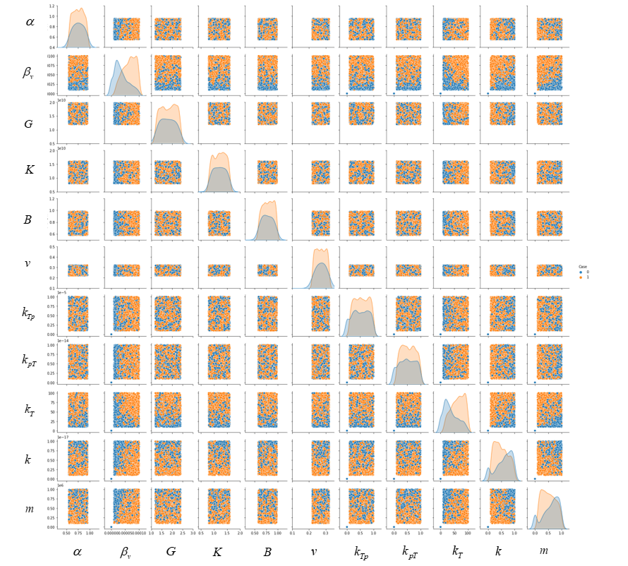

Pairwise bivariate distributions for eleven variables (each orange color dot represents a tensile case and each blue color dot represents a compressive case)

References

Ahmed, S., Salehi, S., & Ezeakacha, C. (2020). Review of gas migration and wellbore leakage in liner hanger dual barrier system: Challenges and implications for industry. *Journal of Natural Gas Science and Engineering, 78*, 103284.

Allahvirdizadeh, P. (2020). A review on geothermal wells: Well integrity issues. *Journal of cleaner production, 275*, 124009.

Banthia, N., & Mindess, S. (1989). Water permeability of cement paste. *Cement and concrete research, 19*(5), 727-736.

Bear, J., & Corapcioglu, M. (1981). A mathematical model for consolidation in a thermoelastic aquifer due to hot water injection or pumping. *Water Resources Research, 17*(3), 723-736.

Biot, M. A. (1977). Variational Lagrangian-thermodynamics of nonisothermal finite strain mechanics of porous solids and thermomolecular diffusion. *International Journal of Solids and Structures, 13*(6), 579-597.

Cai, W., Deng, J., Luo, M., Feng, Y., Li, J., & Liu, Q. (2022). Recent advances of cementing technologies for ultra-HTHP formations. *International Journal of Oil, Gas and Coal Technology, 29*(1), 27-51.

Carnahan, C. (1983). Thermodynamic coupling of heat and matter flows in near-field regions of nuclear waste repositories. *MRS Online Proceedings Library (OPL), 26*.

Chen, G., & Ewy, R. T. (2005). Thermoporoelastic effect on wellbore stability. *SpE Journal, 10*(02), 121-129.

Cheng, A. H.-D. (2016). *Poroelasticity* (Vol. 27): Springer.

DeBruijn, G., Skeates, C., Greenaway, R., Harrison, D., Parris, M., James, S., . . . Temple, L. (2008). High-pressure, high-temperature technologies. *Oilfield Review, 20*(3), 46-60.

Delaney, P. T. (1982). Rapid intrusion of magma into wet rock: Groundwater flow due to pore pressure increases. *Journal of Geophysical Research: Solid Earth, 87*(B9), 7739-7756.

Denbigh, K. (1949). Thermo-osmosis of gases through a membrane. *Nature, 163*(4132), 60-60.

Derski, W. (1979). Equations of linear thermoconsolidation. *Archives of Mech., 31*(3), 303-316.

Detournay, E., & Cheng, A.-D. (1988). Poroelastic response of a borehole in a non-hydrostatic stress field. *International Journal of Rock Mechanics and Mining Sciences & Geomechanics Abstracts, 25*(3), 171-182.

Detournay, E., & Cheng, A. H.-D. (1993). Fundamentals of poroelasticity. In *Analysis and design methods* (pp. 113-171): Elsevier.

Drake, J. A., Bradford, A., & Marsalek, J. (2013). Review of environmental performance of permeable pavement systems: state of the knowledge. *Water Quality Research Journal of Canada, 48*(3), 203-222.

Eshraghi, D. (2013). *P&A-status on regulations and technology, and identification of potential improvements.* University of Stavanger, Norway,

Gao, J., Deng, J., Lan, K., Song, Z., Feng, Y., & Chang, L. (2017). A porothermoelastic solution for the inclined borehole in a transversely isotropic medium subjected to thermal osmosis and thermal filtration effects. *Geothermics, 67*, 114-134.

Ge, Z., Yao, X., Wang, X., Zhang, W., & Yang, T. (2018). Thermal performance and microstructure of oil well cement paste containing subsphaeroidal konilite flour in HTHP conditions. *Construction and Building Materials, 172*, 787-794.

Ghabezloo, S., & Sulem, J. (2010). Temperature induced pore fluid pressurization in geomaterials. *arXiv preprint arXiv:1011.6501*.

Ghassemi, A., & Diek, A. (2002). Porothermoelasticity for swelling shales. *Journal of Petroleum Science and Engineering, 34*(1-4), 123-135.

Ghassemi, A., Tao, Q., & Diek, A. (2009). Influence of coupled chemo-poro-thermoelastic processes on pore pressure and stress distributions around a wellbore in swelling shale. *Journal of Petroleum Science and Engineering, 67*(1-2), 57-64.

Gomar, M., Goodarznia, I., & Shadizadeh, S. R. (2014). Transient thermo-poroelastic finite element analysis of borehole breakouts. *International Journal of Rock Mechanics and Mining Sciences, 71*, 418-428.

Gonçalvès, J., & Trémosa, J. (2010). Estimating thermo-osmotic coefficients in clay-rocks: I. Theoretical insights. *Journal of colloid and interface science, 342*(1), 166-174.

Goto, S., & Roy, D. M. (1981). The effect of w/c ratio and curing temperature on the permeability of hardened cement paste. *Cement and concrete research, 11*(4), 575-579.

Gruber, S., & Plank, J. (2021). Challenges in Cementing Deep Offshore Wells. *Vietnam Symposium on Advances in Offshore Engineering*, 459-466. doi:<https://doi.org/10.1007/978-981-16-7735-9_5>

Hargis, C. W., Chen, I. A., Devenney, M., Fernandez, M. J., Gilliam, R. J., & Thatcher, R. P. (2021). Calcium Carbonate Cement: A Carbon Capture, Utilization, and Storage (CCUS) Technique. *Materials, 14*(11), 2709.

Katende, A., Lu, Y., Bunger, A., & Radonjic, M. (2020). Experimental quantification of the effect of oil based drilling fluid contamination on properties of wellbore cement. *Journal of Natural Gas Science and Engineering, 79*, 103328.

Khalifeh, M., & Saasen, A. (2020). *Introduction to permanent plug and abandonment of wells*: Springer Nature.

Khalili, N., Geiser, F., & Blight, G. (2004). Effective stress in unsaturated soils: Review with new evidence. *International journal of Geomechanics, 4*(2), 115-126.

Kiran, R., Teodoriu, C., Dadmohammadi, Y., Nygaard, R., Wood, D., Mokhtari, M., & Salehi, S. (2017). Identification and evaluation of well integrity and causes of failure of well integrity barriers (A review). *Journal of Natural Gas Science and Engineering, 45*, 511-526.

Koťátková, J., Zatloukal, J., Reiterman, P., & Kolář, K. (2017). Concrete and cement composites used for radioactive waste deposition. *Journal of environmental radioactivity, 178*, 147-155.

Krakowiak, K. J., Thomas, J. J., James, S., Abuhaikal, M., & Ulm, F.-J. (2018). Development of silica-enriched cement-based materials with improved aging resistance for application in high-temperature environments. *Cement and concrete research, 105*, 91-110.

Kurashige, M. (1989). A thermoelastic theory of fluid-filled porous materials. *International Journal of Solids and Structures, 25*(9), 1039-1052.

Massion, C., Radonjic, M., Lu, Y., Bunger, A., & Crandall, D. (2021). *Impact of Graphene and the Testing Conditions on the Wellbore Cement Mechanical and Microstructural Properties.* Paper presented at the 55th US Rock Mechanics/Geomechanics Symposium, Paper number: ARMA 21–2089 20-23, June, 2021, Houston, Texas.

Massion, C., Vissa, V. S., Lu, Y., Crandall, D., Bunger, A., & Radonjic, M. (2022). Geomimicry-Inspired Micro-Nano Concrete as Subsurface Hydraulic Barrier Materials: Learning from Shale Rocks as Best Geological Seals. In *REWAS 2022: Energy Technologies and CO2 Management (Volume II)* (pp. 129-138): Springer.

Meng, M., Frash, L. P., Carey, J. W., Li, W., Welch, N. J., & Zhang, W. (2021). Cement stress and microstructure evolution during curing in semi-rigid high-pressure environments. *Cement and concrete research, 149*, 106555.

Olson, J., Eustes, A., Fleckenstein, W., Eker, E., Baker, R., & Augustine, C. (2015). Completion Design Considerations for a Horizontal Enhanced Geothermal System. *GRC Transactions, 39*, 335-344.

Picandet, V., Rangeard, D., Perrot, A., & Lecompte, T. (2011). Permeability measurement of fresh cement paste. *Cement and concrete research, 41*(3), 330-338.

Qin, J., Pang, X., Cheng, G., Bu, Y., & Liu, H. (2021). Influences of different admixtures on the properties of oil well cement systems at HPHT conditions. *Cement and Concrete Composites, 123*, 104202.

Roshan, H., Andersen, M., & Acworth, R. (2015). Effect of solid–fluid thermal expansion on thermo-osmotic tests: an experimental and analytical study. *Journal of Petroleum Science and Engineering, 126*, 222-230.

Samarakoon, M., Ranjith, P., & Wanniarachchi, W. (2022). Properties of well cement following carbonated brine exposure under HTHP conditions: A comparative study of alkali-activated and class G cements. *Cement and Concrete Composites, 126*, 104342.

Sarout, J., & Detournay, E. (2011). Chemoporoelastic analysis and experimental validation of the pore pressure transmission test for reactive shales. *International Journal of Rock Mechanics and Mining Sciences, 48*(5), 759-772.

Scholz, M., & Grabowiecki, P. (2007). Review of permeable pavement systems. *Building and environment, 42*(11), 3830-3836.

Shapiro, A. (2003). Monte Carlo sampling methods. *Handbooks in operations research and management science, 10*, 353-425.

Skempton, A. (1984). Effective stress in soils, concrete and rocks. *Selected papers on soil mechanics, 1032*(3), 4-16.

Smith, D. W., & Booker, J. R. (1993). Green's functions for a fully coupled thermoporoelastic material. *International Journal for Numerical and Analytical Methods in Geomechanics, 17*(3), 139-163.

Snee, J.-E. L., & Zoback, M. D. (2018). State of stress in the Permian Basin, Texas and New Mexico: Implications for induced seismicity. *The Leading Edge, 37*(2), 127-134.

Song, Z., Liang, F., Lin, C., & Xiang, Y. (2019). Interaction of pore pressures in double-porosity medium: Fluid injection in borehole. *Computers and Geotechnics, 107*, 142-149.

Stehfest, H. (1970). Algorithm 368: Numerical inversion of Laplace transforms [D5]. *Communications of the ACM, 13*(1), 47-49.

Tao, Q., & Ghassemi, A. (2010). Poro-thermoelastic borehole stress analysis for determination of the in situ stress and rock strength. *Geothermics, 39*(3), 250-259.

Trémosa, J., Gonçalvès, J., Matray, J., & Violette, S. (2010). Estimating thermo-osmotic coefficients in clay-rocks: II. In situ experimental approach. *Journal of colloid and interface science, 342*(1), 175-184.

Valov, A., Golovin, S., Shcherbakov, V., & Kuznetsov, D. (2022). Thermoporoelastic model for the cement sheath failure in a cased and cemented wellbore. *Journal of Petroleum Science and Engineering, 210*, 109916.

Vrålstad, T., Saasen, A., Fjær, E., Øia, T., Ytrehus, J. D., & Khalifeh, M. (2019). Plug & abandonment of offshore wells: Ensuring long-term well integrity and cost-efficiency. *Journal of Petroleum Science and Engineering, 173*, 478-491.

Wang, H. F. (2017). *Theory of linear poroelasticity with applications to geomechanics and hydrogeology*: Princeton University Press.

Wang, Y., & Dusseault, M. B. (2003). A coupled conductive–convective thermo-poroelastic solution and implications for wellbore stability. *Journal of Petroleum Science and Engineering, 38*(3-4), 187-198.

Weisstein, E. W. (2002). Eigen decomposition. [*https://mathworld*](https://mathworld)*. wolfram. com/*.

Xu, S., & Zoback, M. D. (2015). *Analysis of stress variations with depth in the Permian Basin Spraberry/Dean/Wolfcamp Shale.* Paper presented at the 49th US Rock Mechanics/Geomechanics Symposium, Paper number: ARMA-2015-189, June 28, 2015, San Francisco, California.

Zhou, X., & Ghassemi, A. (2009). Finite element analysis of coupled chemo-poro-thermo-mechanical effects around a wellbore in swelling shale. *International Journal of Rock Mechanics and Mining Sciences, 46*(4), 769-778.

Zoback, M., Barton, C., Brudy, M., Castillo, D., Finkbeiner, T., Grollimund, B., . . . Wiprut, D. (2003). Determination of stress orientation and magnitude in deep wells. *International Journal of Rock Mechanics and Mining Sciences, 40*(7-8), 1049-1076.